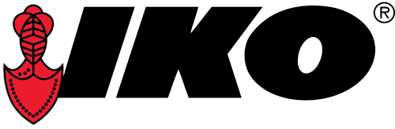

**Production Operator – Full Time**

Rotating Shifts with most Weekends Off!

State-of-the-Art Plant Highly Automated Competitive Wage Paid Uniforms/Laundry Positive Work Culture Family owned/Operated Stability Open Communication

**Work with a great Team to operate automated equipment in the production and recycling of our flat roofing products. Handle raw and finished materials and document processes for success. Use forklift and automated equipment to meet manufacturing standards.**

**Required Education and Experience**

* Experience in medium to heavy-industrial manufacturing, construction, or similar industry preferred
* Minimum of one (1) year counter-balance forklift experience
* Fluent in verbal and written English

**Starting Rate is $25.21 per hour**

**Physical Demands**

While performing the duties of this job, the employee is regularly required to talk or hear. The employee is frequently required to stand; walk; use hands to handle or feel (manual dexterity); and reach with hands and arms. This position is active and requires standing, walking, bending, kneeling, stooping, crouching, crawling and climbing all day. Employee must be able to work at heights and in confined spaces. The employee must frequently lift and move items over fifty (50) pounds. Specific vision abilities for this job include close vision, distance vision, color vision, peripheral vision, depth perception and ability to focus.

For a complete job description, please see our posting - [www.ikocareers.com](http://www.ikocareers.com)

IKO provides medical, dental, vision, life insurance, matching 401K, shingle discounts. Vacation and Sick benefits are also available.