**Episode 5 Show Notes**



**Portion control using an ice cream scoop:**

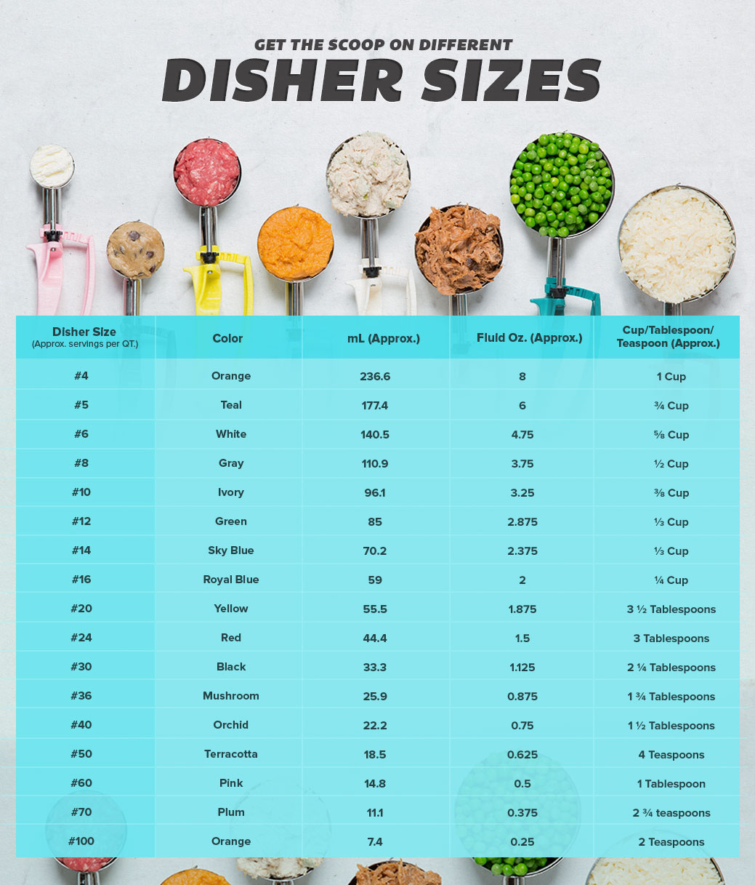

**Recipe of The Week!  
Honey Radishes**

**Courtesy of Chef Miriam Conroy**

**Yield: 2 Cups**

**Ingredients:**

2 Cups Radishes, quartered

1 Shallot, finely minced

1 Tbsp. Olive Oil

½ Cup Honey

1 Cup White Wine

TT Salt

TT White Pepper

**Method:**

Sweat the shallot in the olive oil over medium heat

Add the radishes, honey, white wine, and salt and pepper

Bring to a simmer and cook until the wine and honey become syrupy and the radishes are tender-crisp.